Jason Meyer
Cooksey Communications
972-580-0662 x 21
jason@cookseypr.com

Mercedes Bolen
Hillwood Properties
817-224-6002
mercedes.bolen@hillwood.com

FOR IMMEIDATE RELEASE

FRISCO STATION PARTNERSHIP ENGAGES HILLWOOD MULTIFAMILY TO START FIRST URBAN LIVING COMMUNITY

AT FRISCO STATION

Station House community to begin construction in the

highly anticipated Frisco Station development

FRISCO, Texas (December 7, 2016) – The Frisco Station Partnership has engaged Hillwood Multifamily, LP, the multifamily division of Hillwood, to develop Station House, a
300-unit urban living community in Frisco, Texas. Station House will be the first residential project to break ground in Frisco Station, a 242-acre multi-use development at the northwest quadrant of the Dallas North Tollway and Warren Parkway.

In addition to Hillwood, the Frisco Station development partnership also includes the Rudman Partnership, which has owned the Frisco Station land since 1962, and Van Trust Real Estate, which serves as the office development partner.

“Located in the heart of Frisco Station, and adjacent to the new Dallas Cowboys Star project, we believe Station House will set a new standard for urban lifestyle living in the Frisco market with a focus on healthy, smart and creative design principles targeting residents ranging from young professionals to empty-nesters,” said Mark McHenry, managing director of Hillwood Multifamily. “The job growth in this region is creating strong demand for new housing in the Frisco community, and Station House will provide a highly amenitized urban lifestyle product to an area that needs more housing options to meet the growing demand.”

Designed by JHP Architecture/Urban Design, Station House will be a four-story contemporary, urban-style community with controlled-access, structured garage parking. Apartment homes will feature energy-efficient, stainless steel appliances and LED lighting. Additional design amenities include a full suite of luxury finishes including espresso stained wood cabinetry, urban mudrooms, butler’s pantry, built-in desks, oversized soaking tubs and walk-in showers, custom lighting fixtures, island kitchens with quartz and granite counter tops, satin-brushed nickel plumbing fixtures, walk-in closets, and 10-foot ceilings.

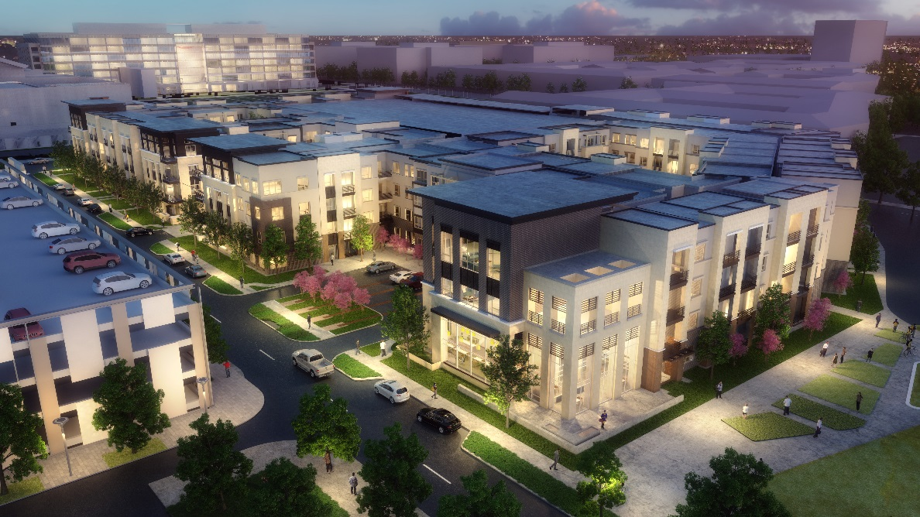

While the units will be highly amenitized, community spaces that are designed to facilitate resident engagement are also a central feature of Station House. The community will provide a wide array of lifestyle amenities including private interior courtyards with pool area; outdoor kitchen and social spaces; state-of-the-art fitness center with yoga and interactive studio; wellness lounge with private dry bar; massage room and pilates studio; coffee bar and wine bar; resident lounge and library; demonstration kitchen and private dining room; game room with multiple gaming opportunities; and terrace lounges for indoor and outdoor entertaining. Residents may also participate in planned programming at Frisco Station’s 15-acre park.

The community will also include advanced technology for high-speed wireless connectivity in the public areas. Bike storage and repair stations, a dog wash and grooming station, valet trash and recycling services are additional amenities for residents of this smoke-free community.

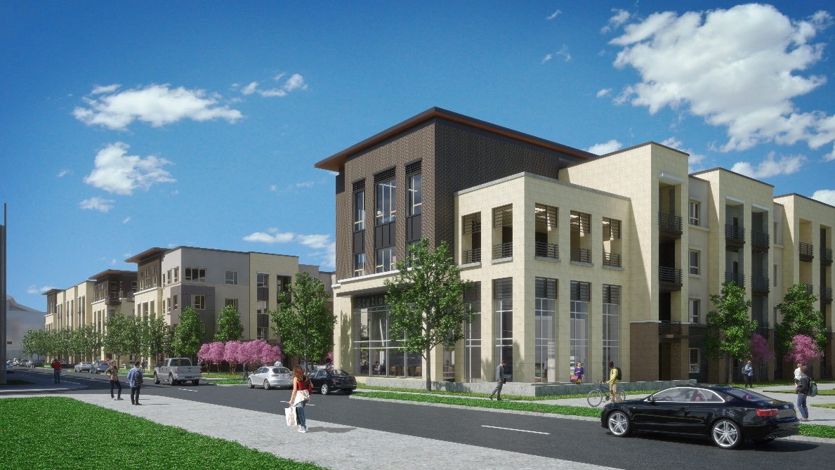

Financing for Station House was provided through the Dallas office of Associated Bank, a U.S. regional bank providing retail banking, commercial banking, commercial real estate lending, private banking, specialized financial services and insurance services. This is the first Texas project on which Associated Bank has partnered with Hillwood, and the second project nationally.

“Hillwood is one of the leading developers in the North Texas market and we are excited about this sponsorship opportunity for Station House, which we believe will serve as a critical piece of Frisco Station,” said Kevin Jordan, senior vice president and market manager in the Commercial Real Estate Division for Associated Bank. “Station House is in an awesome location and we are extremely optimistic that it will become one of the region’s premier urban living communities.”

Station House is the first urban living project at Frisco Station, which will ultimately provide up to 2,400 urban living residential homes. The project is located within walking distance to Frisco Station’s dining and entertainment district, called “The Hub,” which is being programmed with a unique mix of food, beverage and entertainment destinations. Station House is also adjacent to the first phase of Frisco Station’s 25-acre master planned open space and trail system.

Earlier this year, the Frisco Station Partnership announced plans to develop a 228,000-square-foot, Class A multi-tenant building at Frisco Station. The project is the first offering of a total of 5 million square feet of planned office space for Frisco Station, which will include 1.5 million square feet of mid-rise office space and 1 million square feet for campus-style office. Construction on the seven-story, mid-rise office tower is underway by Frisco Station Partner, VanTrust, and slated for completion in August 2017.

Uniquely positioned in one of the most dynamic development corridors in North Texas, Frisco Station promotes the experiential convergence of smart, creative and healthy principles with a new approach to urban design. In addition to the urban living, restaurant and entertainment, office and corporate campus development components, the master plan for Frisco Station includes 500,000 square feet of medical and wellness facilities, and open space/greenbelt amenities with programmed events and public activities. The development will feature a high-tech, creative and innovative environment that fosters wellness and a sense of place, as well as stimulates inspiration and energy.

Frisco Station will encourage activity and nurture thoughtful design through the latest health and wellness concepts, entertainment venues, specialty retail shops and restaurants, medical centers, and open spaces with programmed events and public engagements. The entire development is designed to meet the new paradigm for corporate employers seeking office space in walkable communities offering their employees a full range of lifestyle amenities within close proximity to their jobs.

About Frisco Station
Frisco Station is a 242-acre mixed-use development in Frisco, Texas created with a new approach to urban design based on the foundational principles of smart, creative and healthy experiences. The proposed development is located to the west of the Dallas North Tollway and to the north of Warren Parkway surrounding the new Dallas Cowboys Star development and world headquarters complex. Frisco Station will feature fully amenitized office, residential, retail, restaurant and medical uses. Frisco Station will be an innovative corporate, retail and medical destination in Frisco, featuring modern amenities, technological connectivity and flexible workspaces within a vibrant economic climate.

# # #

